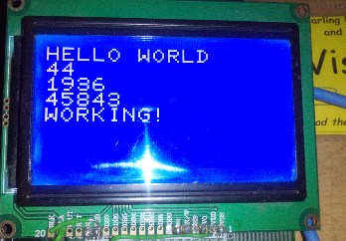So, this is a sort of actually working BASIC program here.

The interpreter bit is almost complete – the only thing missing is the GOTO statement which as this is a transport architecture is the # variable – e.g. #=40 is the same as GOTO 40.

The program being run (on the real hardware …) is as follows:

105 $=12

108 ?="HELLO WORLD"

110 A=?

120 B=A*A

125 ?=B

130 C='

140 ?=""

145 ?=C

150 ?=""

160 ?="WORKING!"

* $=12 sends chr(12) to the screen driver which clears the screen.
* ?= “xxx” prints xxx and ?=B prints the contents of variable B
* A=? inputs a number (here I have typed in 44 on the keyboard you can’t see, which Is squared and printed out)
* C=’ puts a random number in C (this is the 45843 value)

Okay, so it’s not exactly the most complex code ever written, but it is working as it should, and it picks up errors (the original VTL-2 will run almost anything you ask it to however syntactically wrong)